Healing Properties of Herbs & Oils

DISCLAIMER – MUST READ!

The following information contained in these pages is for educational and informational purposes only and is not intended as medical advice. The information herein comes from herbal and botanical sources throughout history and cannot be guaranteed the cause and effect in which these herbs and remedies create.

All persons using this material as reference agree to accept full responsibility for any results experienced by using them. You are responsible for your own health. As with conventional medicine, herbal medicine is vast and complex, and must be used responsibly. People react differently to different remedies. Some herbs are contraindicated with certain pharmaceutical drugs. Further, some helpful herbs may be confused with harmful and/or deadly substances. There are many plants and mushrooms that can make you sick or are deadly poisonous. Be 100% of your identification before you harvest any plant or mushroom. Additionally, sometimes a new food, even properly identified, can cause an unusual reaction – ranging from gastric intolerance to a full-blown allergy.

I am a medical professional and an Herbalist, but I am not a physician. Only a physician can diagnose, treat, and prescribe for illness or disease. As an Herbalist, I neither diagnose nor treat disease. Nor do I prescribe remedies.

Herbalists are people who dedicate their lives to working with medicinal plants. They include native healers, scientists, naturopaths, holistic medical doctors, researchers, writers, herbal pharmacists, medicine makers, wild crafters, harvesters and herbal farmers to name a few.

FDA Disclaimer: These statements and products have not been evaluated by the FDA. They are not intended to diagnose, treat, cure, or prevent any disease or condition.

*All images copied within are not my own and have been acquired using creative common licensing or properly referenced. These images may be used for personal usage, but not for sale/reproduction as per their copyright.

In Service –

Lady Lasairfhíona inghean Tuathail
Apothecarist, Herbalist, Nurse

Healing Properties of Plants/Oils

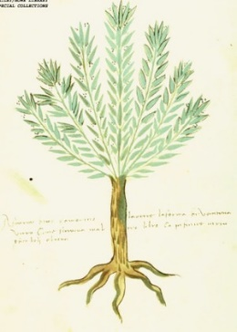
Rosemary (Rosmarinus officinalis)
This herb, especially the flower tops, contains antibacterial and antioxidant rosmarinic acid, plus several essential oils such as cineol, camphene, borneol, bornyl acetate, and α-pinene that are known to have anti-inflammatory, anti-fungal, and antiseptic properties.

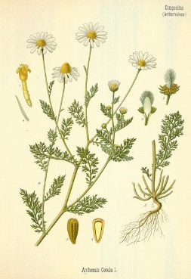
Chamomile (Matricaria chamomilla)
Chamomile is commonly used for improving many different health conditions, including: Fighting anxiety and depression. Natural allergy fighter or hay fever. Anti-inflammatory. Muscle spasms treatment. PMS natural remedy and other menstrual disorders. Insomnia cure. Skin disorders. Ulcers.

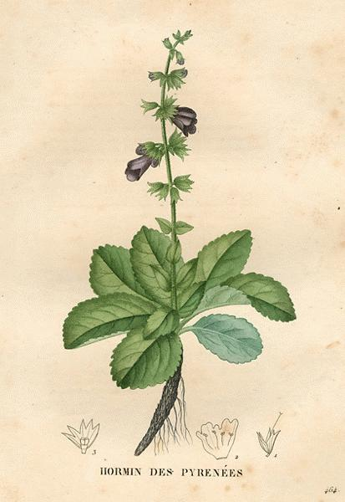
Greek Mountain Sage (Salvia officinalis)
The leaf is used to make medicine. Sage is used for digestive problems, including loss of appetite, gas (flatulence), stomach pain (gastritis), diarrhea, bloating, and heartburn. It is also used for reducing overproduction of perspiration and saliva; and for depression, memory loss, and Alzheimer's disease.

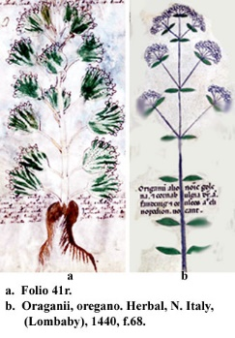
Greek Mountain Oregano (Origanum vulgare)
The chemicals that give the herb its unique and pleasant smell are thymol, pinene, limonene, carvacrol, ocimene, and caryophyllene. Oregano is a Mediterranean herb that is used for cooking and medicinal purposes, ranging from treating infections to repelling insects. Oregano is a mint so if you are allergic to mint be cautious around Oregano.

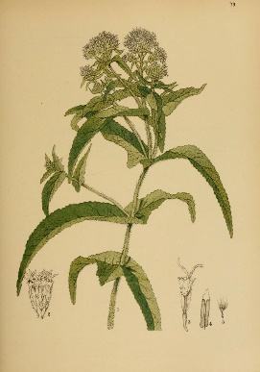
Boneset (Eupatorium perfoliatum)
Therapeutic Benefits, Claims & Traditional Uses of Boneset. The boneset plant has various medical properties such as analgesic, antibacterial, anti-inflammatory, diaphoretic, febrifuge, immune stimulant, laxative, and stimulant.

Mullein (Verbascum Densiflorum)
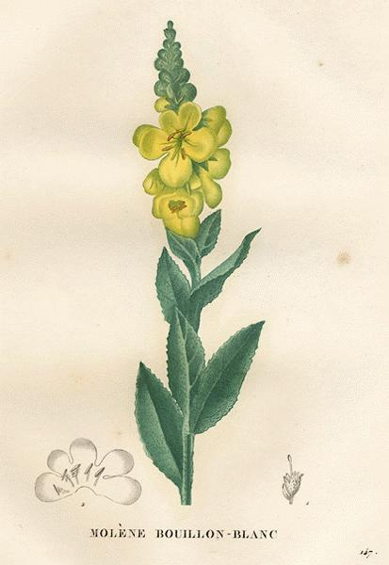
One of the most well-known uses of mullein is its purported ability to help alleviate respiratory conditions. Taken as a tea, it can help with common ailments such as dry cough, congestion and sore throat. It may help with inflammatory respiratory conditions, such as asthma and bronchitis as well. Also, good for bursitis and ear infections.

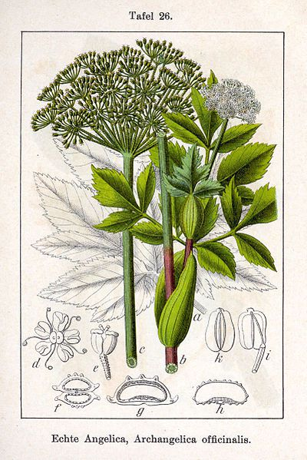
Angelica Root (Angelica archangelica)
The root, seed, and fruit are used to make medicine. Angelica is used for heartburn, intestinal gas (flatulence), loss of appetite (anorexia), arthritis, circulation problems, "runny nose" (respiratory catarrh), nervousness, plague, and trouble sleeping (insomnia). It was the first medicinal plant that was exported from the Nordic countries to the rest of Europe. During the middle ages the root of the plant was believed to be effective as a treatment for the plague and in the 17th and 18th century the herb was widely used against intestinal infections such as dysentery and cholera.
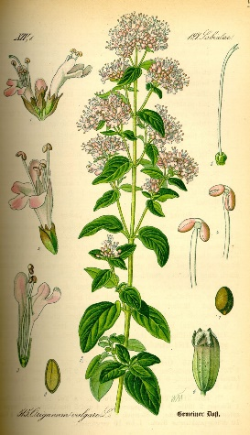
Rue (Ruta graveolens L.)
Rue herb contains volatile oils, alkaloids, flavomoids, lignans and hydroxycoumarins. The herb can boast a variety of medicinal properties including antispasmodic, anti-inflammatory, antimicrobial, antifungal and emmenagogue. Early physicians considered rue an excellent protection against plagues and pestilence, and used it to ward off poisons and fleas. Rue was once believed to improve the eyesight and creativity, and no less personages than Michelangelo and Leonardo Da Vinci regularly ate the small, trefoil leaves to increase their own.

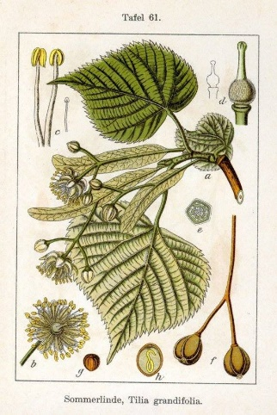
Linden Leaf and Flower (Tilia cordata)
The dried flower, leaves, and wood are used for medicine. Linden leaf is used for colds, stuffy nose, sore throat, breathing problems (bronchitis), headaches, fever, and to make it easier to bring up phlegm by coughing (as an expectorant). Flowers from 2 linden species (Tilia cordata and Tilia platyphyllos) were historically used to soothe nerves and treat health problems associated with anxiety. These flowers were steeped as a tea to relieve anxiety related to indigestion, irregular heartbeat, and vomiting.

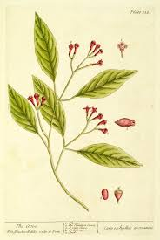
Cloves (Syzygium aromaticum)
Clove, just like many other spices originating in Asia, has a great history behind it. During the 13th and 14th centuries, cloves were transported all the way from Indonesia to China, India, Persia, Africa, and Europe. During this time, cloves had a very high price, and thus wars for monopoly over clove production and distribution began. Many wars were waged in order to control the islands of Maluku during both the medieval and modern periods. The Dutch emerged victoriously and held the Maluku islands for a very long time. Today, clove is a very important commercial crop all around the world. Cloves offer many health benefits, some of which include aiding in digestion, fighting against cancer, protecting the liver, boosting the immune system, controlling diabetes, and preserving bone quality. They also contain anti-mutagenic and anti-microbial properties, along with fighting against oral diseases and headaches, while also displaying aphrodisiac properties.

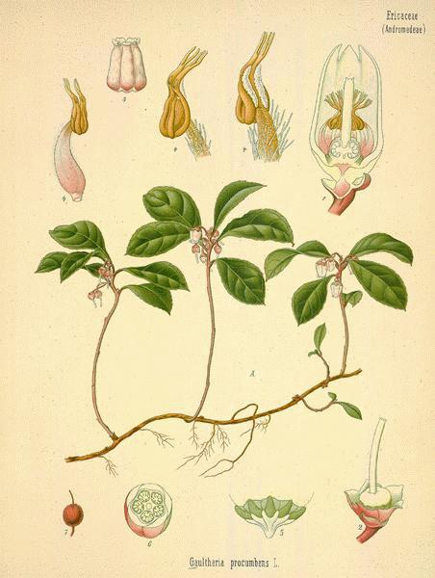
Wintergreen Leaf (Gaultheria procumbens)
Wintergreen is used in stouts, fruit beers and holiday ales. While many people confuse wintergreen with mint, they are not related in any way. It goes by many names: teaberry, checkerberry, dearberry, spiceberry, boxberry, and even a tea party. The oils in the plant, which were once used to soften leather for book binding, absorb and convert ultraviolet light into blue light that is visible to the naked eye. The leaves and oil are used to make medicine. Wintergreen leaf is used for painful conditions including headache, nerve pain (particularly sciatica), arthritis, ovarian pain, and menstrual cramps.

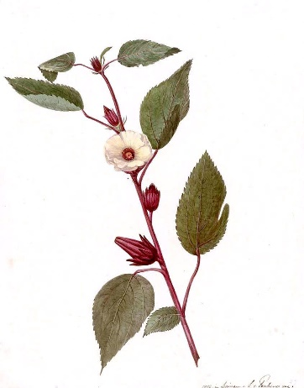
Sorrel Hibiscus (Jamaican Sorrel) (Hibiscus sabdariffa)
It is mostly used for the treatment of high blood pressure, high cholesterol, digestive system issues, boosting the immune system, inflammatory issues, curing liver problems and reducing cancer risks. Some researchers think that other chemicals in hibiscus might be able to decrease spasms in the stomach, intestines and uterus; and work like antibiotics to kill bacteria and worms. It also said to help with colds and nerve diseases, upper respiratory tract pain and swelling (inflammation), fluid retention and disorders of circulation; for dissolving phlegm; as a gentle laxative and as a diuretic to increase urine output. It is slightly tart but very refreshing and can be drank hot or cold. It is also used in various countries such as China and India and has many names such as Sour Tea, Hibiscus Flower Tea, Sorrel and Jamaica.

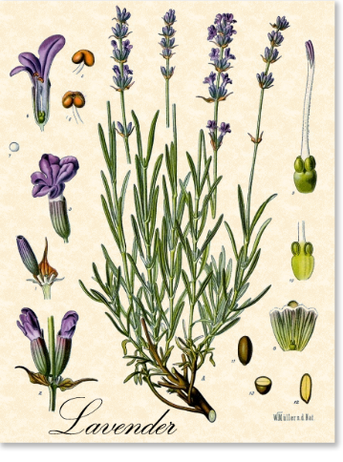
Lavender (Lavandula angustifolia and Lavandula officinalis)
Lavender oil is known for its anti-inflammatory, antifungal, antidepressant, antiseptic, antibacterial and antimicrobial properties. It also has antispasmodic, analgesic, detoxifying, hypotensive and sedative effects. Lavender oil is one of the most well-known essential oils in aromatherapy.
It goes great in cooking, making lavender salts and sugars, baking, teas,

Sweet Orange (Citrus aurantium (LINN.), var. dulcis)
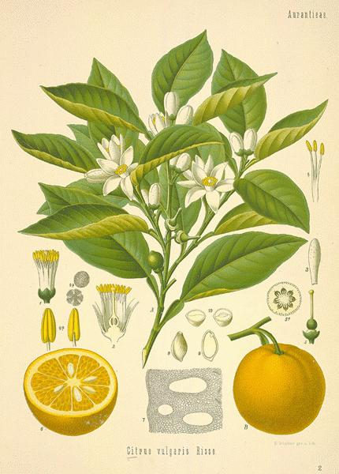
Sweet Orange oil comes from the orange blossoms of orange trees. While not completely medicinal, the oils are used for flavoring and can be used in conjunction with other oils to treat Bronchitis. The oils work great in perfume fragrances and can be simmered with the orange peels in water to create a fresh and clean citrusy scent throughout.

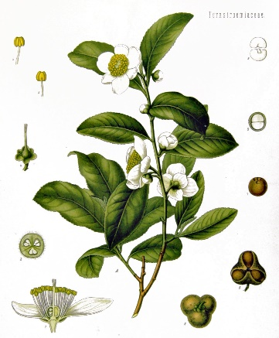
Tea Tree (Melaleuca alternifolia)
Tea Tree oil is distilled from the leaves of the Melaleuca alternifolia plant, found in Australia. The oil possesses antibacterial, anti-inflammatory, antiviral, and antifungal properties. A person can treat acne, athlete's foot, contact dermatitis or head lice using tea tree oil. Tea Tree Oil is very strong on its own. Make sure to use a carrier oil when using the oil on your skin.

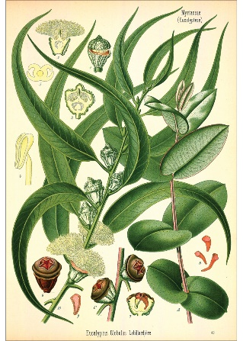
Eucalyptus (Eucalyptus globulus)
Arthritis - potentially due to its anti-inflammatory properties. A blocked nose. Wounds and burns. Ulcers. Cold sores - perhaps due to its anti-inflammatory properties. Bladder diseases. Diabetes - eucalyptus might help lower blood sugar. Fever. Leaves – In both fresh and dried form, leaves of eucalyptus are used as air fresheners and in medicinal teas. Oil – In this form, eucalyptus is added to cough and cold medicines, dental products, antiseptics and used directly to treat fevers. Oils are also used in industrial mining operations and as aromatherapy.
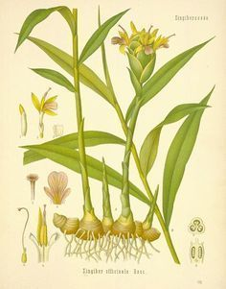
Lemongrass (Cymbopogon)
Lemongrass might help prevent the growth of some bacteria and yeast. Lemongrass also contains substances that are thought to relieve pain and swelling, reduce fever, improve levels of sugar and cholesterol in the blood, stimulate the uterus and menstrual flow, and have antioxidant properties.

Peppermint (Mentha × piperita)
Peppermint is a hybrid of watermint and spearmint. It is available in the forms of leaves, capsules, and oils. Peppermint has shown health benefits for irritable bowel syndrome (IBS), nausea, skin conditions, headaches, improve sleep, relieve menstrual cramps, respiratory properties, cold, and flu.
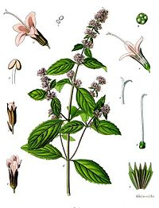

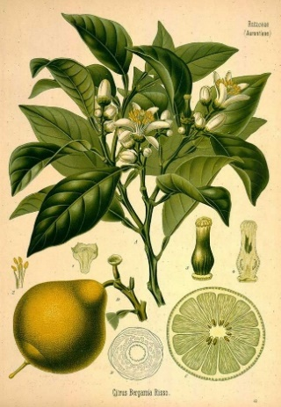
Bergamot (Citrus bergamia)
The citrusy oil is commonly used in flavoring Earl Grey tea, scenting perfumes, and in aromatherapy to reduce anxiety. Additionally, citrus bergamot speeds up healing relieves pain, promotes hormonal balance, alleviates anxiety, lowers blood sugar levels, promotes good cholesterol, and reduces fatty deposits in the liver. Bergamot essential oil is rich in bergamot polyphenols.

Frankincense (Boswellia)
This oil is used to speed up the healing of cuts, acne, burns, rashes and sores. has anti-inflammatory effects that may help reduce joint inflammation caused by osteoarthritis and rheumatoid arthritis. May Improve Gut Function. Improves Asthma. Maintains Oral Health. May Fight Certain Cancers.

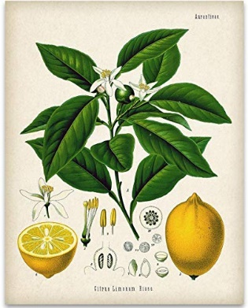
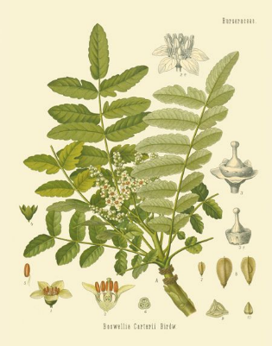
Lemon (Citrus × limon)
Along with its obvious use as a flavor, lemon since long has also been used for its medicinal value. A rich source of vitamin C, lemon possess immense health benefits ranging from its antibacterial and antiviral properties to its immune boosting abilities. Lemon can also prevent kidney stones, protect against anemia, and improve your digestive health.

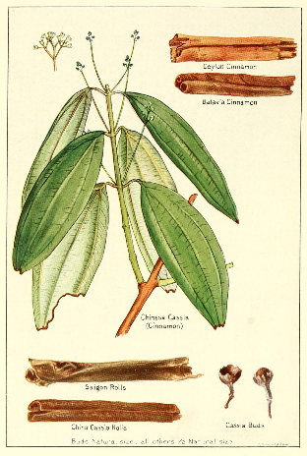
Cinnamon (Cinnamomum verum)
Cinnamon is high in a substance with powerful medicinal properties, loaded with antioxidants, has anti-inflammatory properties, increases circulation, lowers cholesterol, may cut the risk of heart disease, improves brain function, fights infections and viruses, optimizes oral hygiene, prevents candida, can improve sensitivity to the hormone insulin, lowers blood sugar levels and has a powerful anti-diabetic effect.

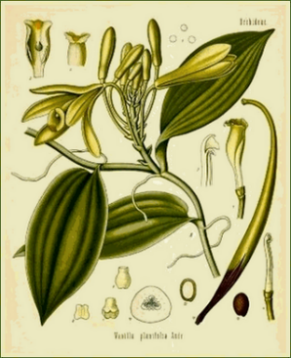
Ylang-Ylang (Cananga odorata)
Ylang ylang oil is made from the flowers of the herb Cananga odorata genuina. People apply ylang ylang oil to the skin to promote relaxation, kill bacteria, lower high blood pressure, and increase sexual desire. It is also part of a combination spray used to kill head lice. It also includes antidepressant, antiseborrheic, antiseptic, anti-inflammatory, properties and can work as a sedative.

Grapefruit (Citrus × paradise)
Grapefruit essential oil is also used to reduce stress, stimulate circulation, increase energy, enhance mood, and improve digestion. When used as an ingredient in personal-care products, grapefruit essential oil is said to treat oily hair and skin.

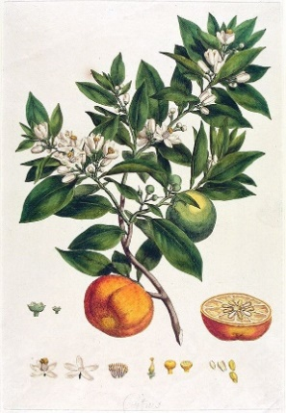
Patchouli (Pogostemon cablin)
Patchouli oil has long been used in traditional Asian medicine, especially in Malaysia, China and Japan. It is used to treat skin and hair problems, such as dermatitis, eczema, acne, dry chapped skin, dandruff, and oily scalp. It also has wound healing and scar reducing properties, as well as aphrodisiac effects. It is known to strengthen hair, fights infections, mood stabilizer, reduces inflammation, and works as a natural deodorant.

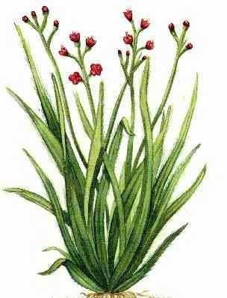
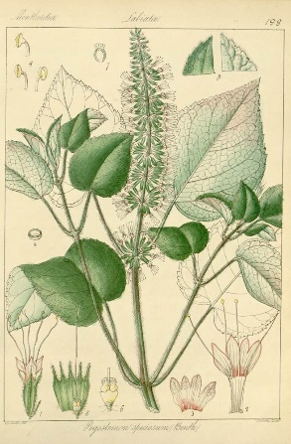
Palmarosa (Cymbopogon martini)
One of the more popular oils is palmarosa, also known as Cymbopogon martinii, which helps treat dry skin, eczema and psoriasis. It is also known to prevent inflammation, prevent dehydration, balances the sebum in your skin, heals cuts and bruises, aids in digestion, heals and remedies acne breakouts.

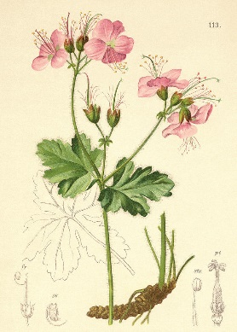
Geranium (Pelargonium)
In aromatherapy, geranium oil is used to help treat acne, sore throats, anxiety, depression and insomnia. It is popular among women due to its rosy smell and its beneficial effect on menstruation and menopause. ... Geranium oil also functions to assist in pain reduction and inflammation. Some of the most common geranium essential oil uses include: Hormone balance. Stress relief. Depression. Inflammation. Circulation. Menopause. Dental health. Blood pressure reduction.

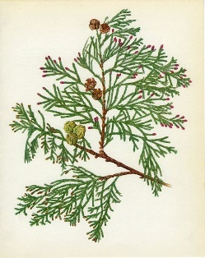
Cypress (Cupressus)

The essential oil has antirheumatic, antispasmodic, anti-inflammatory, antiseptic, astringent, cicatrizant, diuretic, deodorant, febrifuge, sedative, and tonic properties. Heals Wounds and Infections. If you're looking to heal cuts fast, try cypress essential oil. Treats Cramps and Muscle Pulls. Aids Toxin Removal. Promotes Blood Clotting. Eliminates Respiratory Conditions. Natural Deodorant. Relieves Anxiety. Treats Varicose Veins and Cellulite. Cypress oil is generally safe and is non-toxic and non-irritant. However, I do not recommend using it topically without doing a skin patch test.

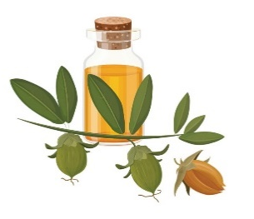
Healing Properties of Oils – Using Carrier Oils

Jojoba (Simmondsia chinensis)
Jojoba is native to the Sonora Desert in northern Mexico and the southwestern United States and has been a highly valued plant for centuries. It is a folk remedy for colds, dysuria, poison ivy, sores, sore throat, warts, and other skin conditions. Native Americans have used jojoba for a wide range of purposes, including applying jojoba oil to wounds and other skin issues. They also applied the oil to aching eyes and joints and drank jojoba preparations for colds and to facilitate childbirth. Jojoba is now cultivated as an oil crop in South America, Africa, and Israel.

Vegetable Glycerin
Vegetable glycerin, or glycerol, is a clear, odorless liquid produced from plant oils, typically palm oil, soy, or coconut oil. Palm and coconut oils are natural triglyceride mixtures; each triglyceride is composed of three fatty acids esterified with glycerin. Vegetable glycerin has a number of valuable applications that include cosmetic products, foods, and as a replacement for alcohol in herbal and botanical tinctures. The hydrating effect of glycerin makes it ideal as a topical remedy for burns. Glycerin is also used in the production of suppositories. A good source to look for is a USP grade, non-GMO, allergen free, kosher certified vegetable glycerin.
Vegetable glycerin used in food applications is USP grade or over 99% pure and has a sweet taste. Vegetable glycerin metabolizes differently than sugar and is used in low carbohydrate foods for sweetness and moisture. Unlike sugar, glycerin does not contribute to tooth decay. Many household products, including lotions, shampoo, and toothpaste, contain vegetable glycerin. Glycerin is added to these products because it is a humectant; a substance that attracts moisture to the skin. In the cosmetic world, this has two practical applications. First, glycerin leaves your skin hydrated. Glycerin soap, for example, is popular for that very reason. Second, for cosmetic products that deliver an active ingredient, a humectant can increase the solubility of the active ingredient, making it more easily absorbed by the skin. Vegetable glycerin may be used as a solvent and substitute for alcohol when producing botanical and herbal extracts. This is advantageous for people who wish to avoid alcohol exposure.
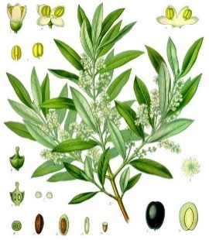
Olive Oil (Olea europea)
Olive oil is used to prevent heart attack and stroke (cardiovascular disease), breast cancer, colorectal cancer, ovarian cancer, rheumatoid arthritis, and migraine headache.
Some people use olive oil to treat constipation, high cholesterol, high blood pressure, blood vessel problems associated with diabetes, and pain associated ear infections, arthritis, and gallbladder disease. Olive oil is also used to treat jaundice, intestinal gas, and meteorism (swelling of the abdomen due to gas). It is also used to destroy the bacteria that causes some ulcers, helicobacter pylori.
Some people also use olive oil to boost bacteria in the gut and as a "cleanser" or "purifier."
Olive oil is applied to the skin (used topically) for earwax, ringing ears (tinnitus), pain in the ears, lice, wounds, minor burns, psoriasis, stretch marks due to pregnancy, eczema, jock itch, ringworm, a skin disease caused tinea versicolor, and for protecting the skin from ultraviolet (UV) damage after sun exposure. In the mouth it is used to reduce gum disease.

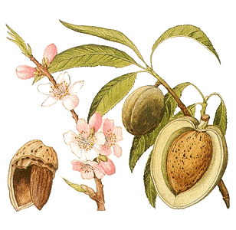
Almond (Prunus amygdalus Batsch)
The Almond tree was initially grown in parts of West Asian and N Africa. The Almond is not a nut, but a seed of the fruit (like an apricot pit). It is one of the most nutritious and natural foods known to man and has amazing health benefits. The presence of manganese, Vit E, copper and riboflavin helps in energy production and metabolic rate.
They are a powerful antioxidant, protecting our cells from damage and helps us maintain a healthy heart and blood vessels. They are high in potassium and protein but low in sodium.

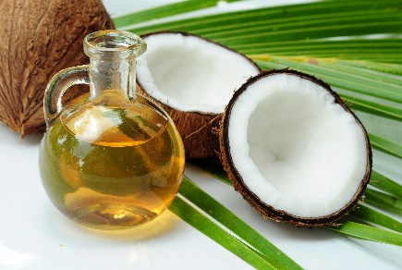
Coconut (Cocos nucifera)
Also called the tree of life, the coconut tree provides a nutritious source of meat, juice, milk, and oil that has fed and nourished populations around the world for generations.
Antifungal and antimicrobial treatment for skin and mouth problems such as ring worms, candidiasis, psoriasis, sores, skin burns, sunburns, toothache, sore throat and ulcers. Coconut oil is massage over the skin as anti-ageing regimen to keep skin soft and youthful looking. Used as oil massage to remove heel cracks and darkening of armpits. Coconut oil is used to treat scalp and hair problems. From greying hair, dandruff to baldness. Coconut oil is an antidote for pesticide poisoning. Coconut water is used to treat colitis, kidney stones, and stomach acidity. Coconut water is also used as diuretic to improve removal of excess water. Coconut water is used for the treatment of urinary tract, gall bladder and kidney problems. Used for the treatment of catarrhal inflammation associated with common colds and coughs. Consume the flesh of Coconut with Coconut Milk and Honey. It increases libido in both men and women. Coconut water is used to treat measles. Coconut oil is good for the immune system. Coconut water is now considered as a potent nutritional source that can boost energy and endurance, enhancing physical and athletic performance.

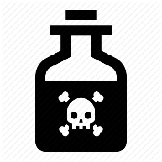
Poisonous Herbs and Plants

Be wary of any of the plants and herbs on this list. While many of the these have been used throughout history to “cure” ailments, botanists have proven that these plants are toxic to ingest or absorb through the skin and could be deadly. These poisons will also harm animals.

Alnwick Castle Poison Garden
Reference: https://www.proflowers.com/blog/poisonous-plants

